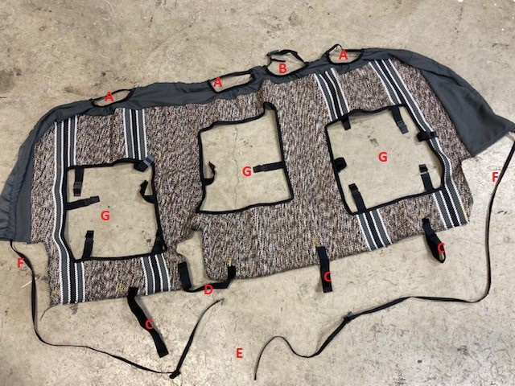

The CRW-10/AR-S seat back piece should look something like this. Please follow along this installation guide.
- Drape cover loosely in place making sure that the headrests at the top are going through the three locations labeled “A” in the picture.
- Ensure that the whole seat cover piece is put behind the centre shoulder seat belt. The mount where the centre shoulder belt comes off the cab of the truck will be located at position”B”. there is a buckle that can be disconnected to go around the back of the seat belt mount.
- The long strap that goes through the knit piece will go all the way around and tuck just behind the perimeter of the seat. At location “F”, the strap will go behind the seat mount at the sides of the seat. It will then join together at location “E” at the bottom of the seat back, only accessible with the two seat bottoms in the up position.
- Tuck the seat cover between the child restraint mounts and the seat itself for better fitment. These will be located close to where the stripes on the seat cover are along the bottom edge.
- The 3 Velcro straps “C” will go all the way to the back firewall of the truck under the seat. They wrap around the metal seat mounts (which you should be able to see a bolt and the mount when the seat bottoms are lifted up) and then stick back on themselves to hold tension.
- The velcro at point “D” will wrap behind the seat fixture and then stick back to the velcro hook tab on the seat cover itself to hold tension.
- All of the elastic/plastic tabs located at locations “G” will be pushed between the plastic mouldings (behind the arm rest and storage doors) and the seat fabric itself to hold tension.
- The storage door covers should just slip over top the door itself with a small hole cut for the pull tab, as well as elastic straps that go across the back of the storage door to hold tension.
- The arm rest will have a cut out for the cupholders and then velcro together along the back side of the arm rest.
- The seat bottoms will slip over the seat covering both sides. The velcro hook along the back edge of the cover will stick directly to the material on the seat itself.

